# 4. Project Planning

## 4.1) WBS (Work Breakdown Structure)

WBS is a fundamental project management technique or method for undertaking the different parts of the application. It will give the vital structure to the itemized direction for schedule development and control. It will further enable us to manage the project and issue.

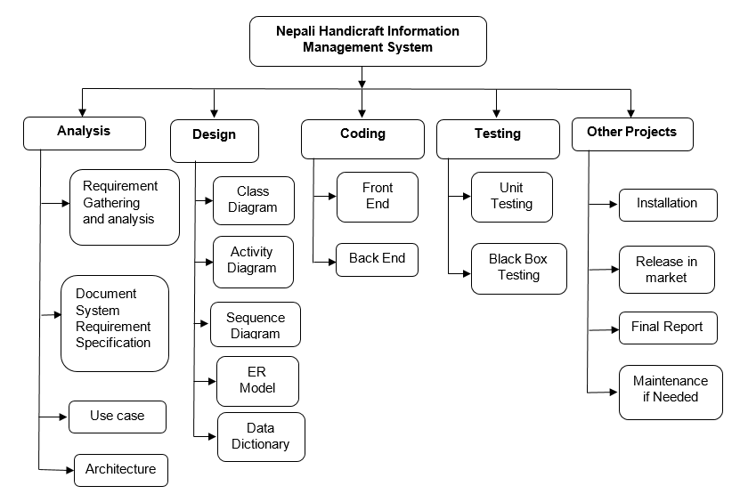

Fig: Work Breakdown Structure

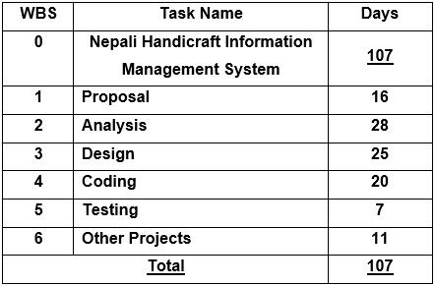

Fig: WBS time estimation

## 4.2) Milestones

It is the task of zero duration that will help to represent a clear and sequence event that incrementally builds up until our project is complete. It will help us to show an important achievement of the project. It will also help to maintain a certain level of progress of the project, and such progress will help us to complete our project on time.

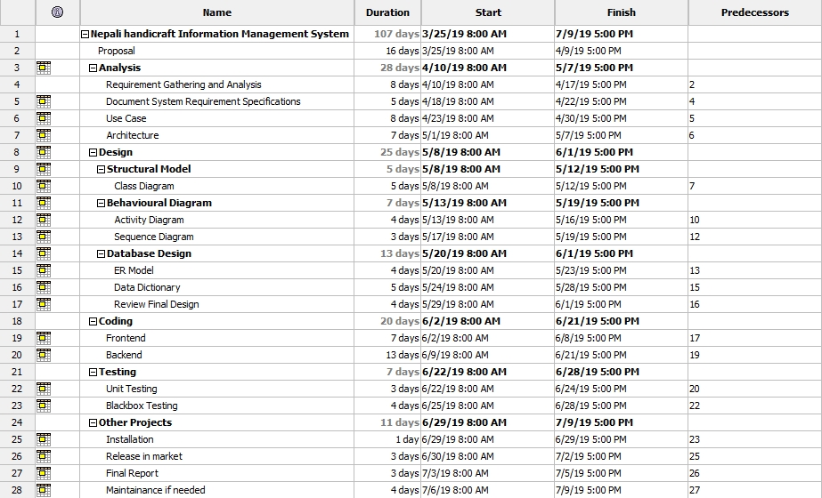

Fig: Milestones

## 4.3) Gantt Chart

Gantt Chart, it is a type of chart which will show the task to be done in a vertical axis and time interval for doing the task on the horizontal axis. We can find the horizontal bars in the graph that will show the length of the particular part of a project to be done.

It is one of the important charts for planning and scheduling our project that will help us to identify how long our project will take to complete and to determine the required resource for the development of the project.

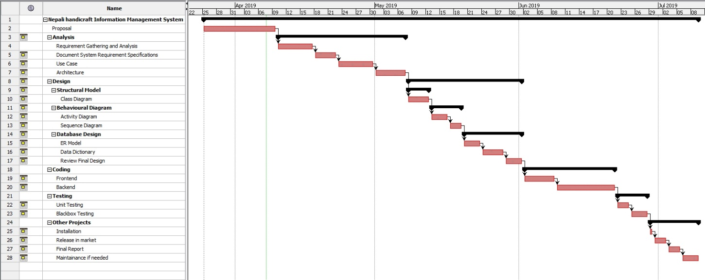

Fig: Gantt Chart